

**North South University**

**Department of Electrical & Computer Engineering**

**LAB REPORT**

**Analog Electronics Lab**

**EEE111L**

**Experiment Number: 4**

**Experiment Name:** **Zener Diode Applications**

**Experiment Date:** 15/11/2021

**Report Submission Date:** 22/11/2021

**Section:** 7 **Group No:** 2

**Students Name & ID:**

1. Tusher Saha Nirjhor – 1921793642 **(Report Writer)**
2. Yusuf Abdullah Tonmoy – 1620456042
3. Fardin Bin Islam - 1721588642
4. Md Kawser Islam – 1912296642
5. Md. Rifat Ahmed – 1931725042

|  |  |  |
| --- | --- | --- |
| **Remarks:** | Score |  |
|  |  |
|  |  |  |
|  |  |  |

**Objectives:**

• Our objective in this experiment is to study the applications of Zener diode.

**Theory:**

A Zener diode is a special type of device designed to operate in the Zener breakdown region. Zener diodes acts like normal p-n junction diodes under forward biased condition but it can also allow electric current in the reverse direction if the applied reverse voltage is greater than the Zener voltage. Zener diode is always connected in reverse direction because it is specifically designed to work in reverse direction.

The Zener Diode is a reverse bias diode that operates at the Zener Voltage (Vz). The study of Zener diode-based networks is quite similar to that of semiconductor diodes.

The Zener diode is a protection device that can be used to establish reference voltage levels. The usage of a Zener diode as a regulator will then be discussed in depth, as it is one of the diode's most common applications. A regulator is a set of components that ensures that a supply's output voltage remains relatively consistent.

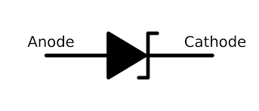

Figure: Zener Diode

The Zener diode used in circuits looks like the above figure.

The use of the Zener diode as a regulator is so common that three conditions surrounding the analysis of the basic Zener regulator are considered.

I. Fixed quantities.

II. Fixed supply voltage and a variable load.

III. Fixed load and a variable supply.

The Zener region is the sudden change in the characteristic at any breakdown voltage. The Zener voltage is the voltage that causes a diode to enter the Zener region of functioning (VZ).

The Zener diode may have a breakdown voltage from about 2 to 200 volts. These diodes can operate in any of three regions – forward, leakage and breakdown. The above figure shows the I-V characteristics curve of the Zener diode.

● In the forward region, it works as an ordinary diode.

● In the leakage region (between zero and breakdown) it has only a small reverse saturation current.

● In the breakdown, it has a sharp knee, followed by an almost vertical increase in current without

changing the voltage.

● The voltage is almost constant, approximately equal to Vz over most of the breakdown region.

Zener Diode Equivalent Circuits: For the equivalent circuit of the Zener Diode, two approximations are employed.

* **First Approximation:** The first approximation considers the Zener diode to be a constant voltage source since the voltage across it remains constant as the current changes across it.
* **Second Approximation:** A Zener resistance is in series with the ideal voltage source is approximated.

**Equipment List:**

• Zener diode (5 volts) – 1 piece

• Resistor (220Ω, 470Ω, 1kΩ) – 1 piece each

• POT (10kΩ) – 1 unit

• Trainer Board

• DC Power Supply

• Digital Multimeter

• Cords and wires

**Circuit Diagram:**

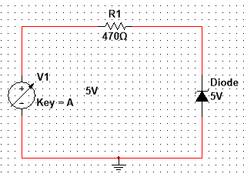

Figure 1 – Reverse Biased Zener Circuit

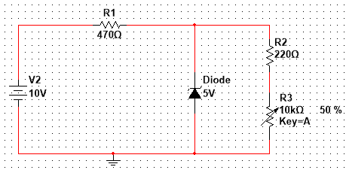

Figure 2 – Load Regulation Circuit

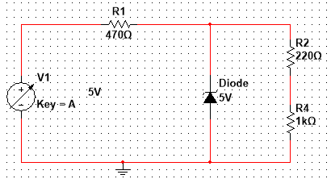

Figure 3 – Line Regulation Circuit

**Data & Table:**

**Table 1: Data for I - V characteristics**

|  |  |  |  |
| --- | --- | --- | --- |
| **V**  **(volts)** | **VR**  **(volts)** | **Vz**  **(volts)** | **Iz = VR / R**  **(mA)** |
| 0.1 | 9.448 µV | 99.991 mV | 19.999 nA |
| 0.3 | 28.342 µV | 299.972 mV | 59.996 nA |
| 0.5 | 47.236 µV | 499.953 mV | 99.992 nA |
| 0.7 | 66.13 µV | 699.934 mV | 139.988 nA |
| 1.0 | 94.472 µV | 999.906 mV | 199.984 nA |
| 2.0 | 188.943 µV | 2 V | 399.969 nA |
| 3.0 | 283.414 µV | 3 V | 599.965 nA |
| 4.0 | 377.885 µV | 4 V | 799.938 nA |
| 5.0 | 92.521 mV | 4.907 V | 196.848 µA |
| 6.0 | 1.044 V | 4.956 V | 2.221 mA |
| 7.0 | 2.031 V | 4.969 V | 4.321 mA |
| 8.0 | 3.023 V | 4.977 V | 6.431 mA |
| 9.0 | 4.017 V | 4.983 V | 8.547 mA |
| 10.0 | 5.013 V | 4.987 V | 10.665 mA |

**Table 2: Data for Load Regulation**

|  |  |  |  |
| --- | --- | --- | --- |
| **POT_R (k**Ω**)** | **V220 (mV)** | **VL (volts)** | **IL (Amp)= V220/220** |
| 1 kΩ | 897.643 mV | 4.978 V | 4.08 mA |
| 2 kΩ | 493.783 mV | 4.983 V | 2.244 mA |
| 3 kΩ | 340.542 mV | 4.984 V | 1.548 mA |
| 4 kΩ | 259.886 mV | 4.985 V | 1.181 mA |
| 5 kΩ | 210.119 mV | 4.986 V | 0.955 mA |
| 6 kΩ | 176.349 mV | 4.986 V | 0.802 mA |
| 7 kΩ | 151.931 mV | 4.986 V | 0.691 mA |
| 8 kΩ | 133.452 mV | 4.986 V | 0.607 mA |
| 9 kΩ | 118.981 mV | 4.986 V | 0.541 mA |
| 10 kΩ | 107.341 mV | 4.986 V | 0.488 mA |

**Table 3: Data for Line Regulation**

|  |  |
| --- | --- |
| **V (volts)** | **VL (volts)** |
| 1.0 | 0.722V |
| 3.0 | 2.166V |
| 6.0 | 4.331V |
| 8.0 | 4.958V |
| 9.0 | 4.97V |
| 10.0 | 4.978V |
| 11.0 | 4.983V |
| 12.0 | 4.988V |

**Result Analysis & Discussion:**

In this experiment at first, we had to build the circuits with different components using Multisim. After that we had to check the value to define points. Then we just had to go to the simulation and parameter sweep to fill up the data table. After that we built the load and line regulation circuit by maintaining the same procedure. We just put the operating point with display results in a table to show the table. After that we have done some calculations to get VR, VZ, IZ, VL, IL etc. Now if we look into the values of Table 3, we can see that the values differ from the values we get after increasing the POT value with 1kΩ. So overall, this lab is very helpful for us as in this lab we learned about the different applications of Zener diode. So, it was a very beneficial lab for us.

**Questions / Answers:**

**Answer to question 1:**

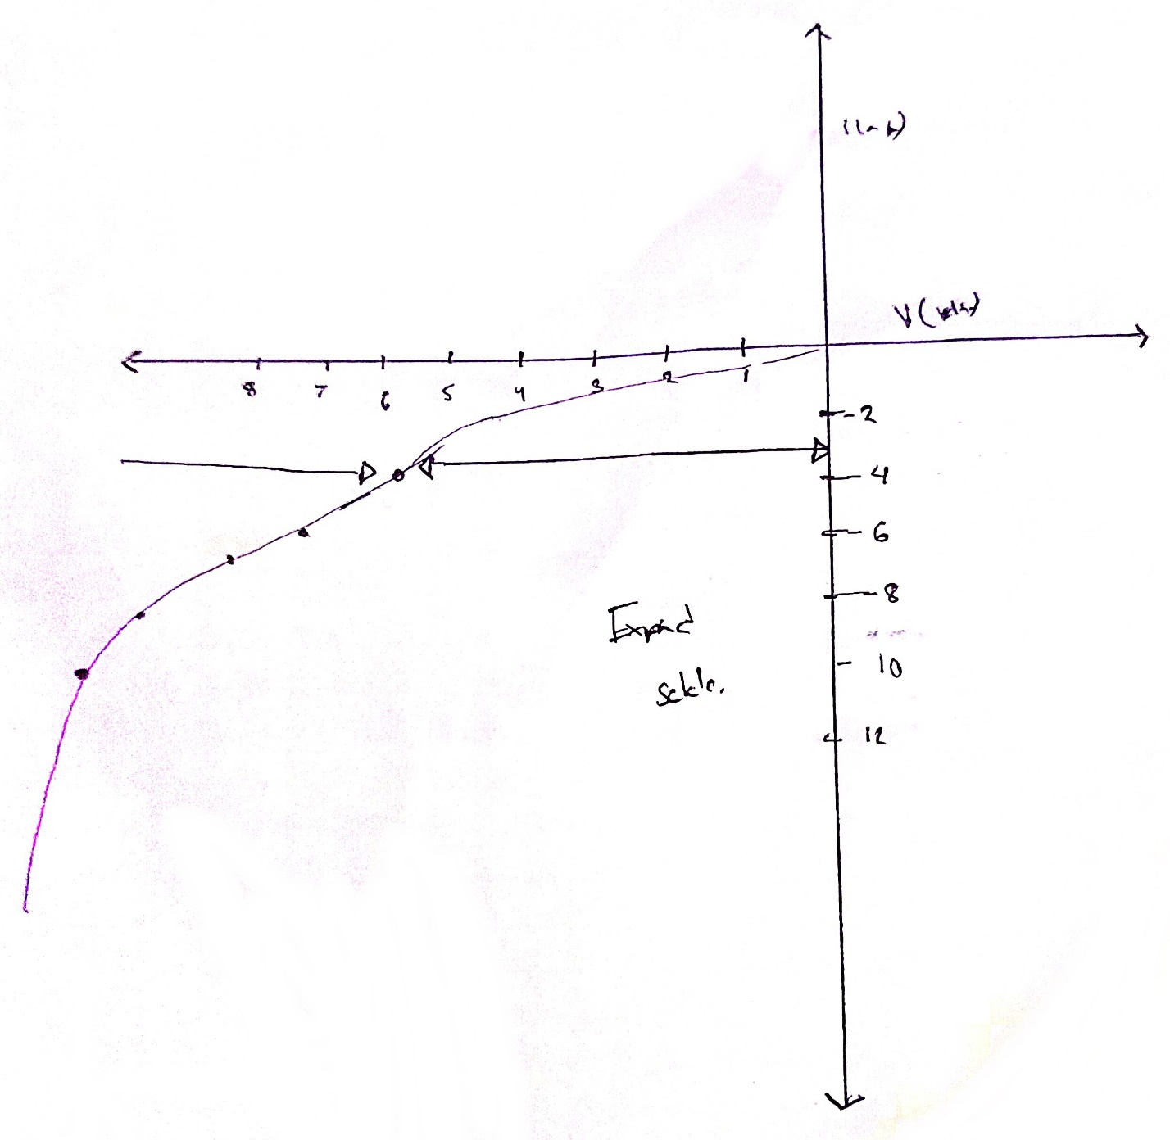

Figure 4: I-V Characteristics Graph of a Zener diode (Reverse Bias Region)

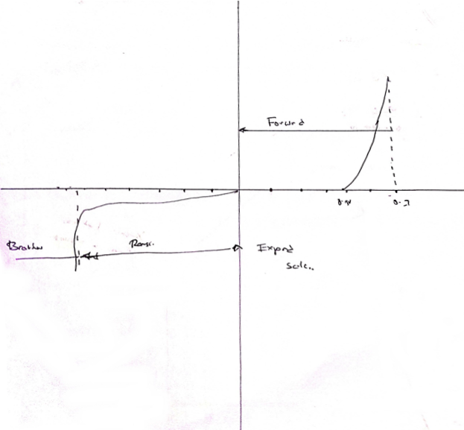

Figure 5: I-V Characteristics Graph of a Zener diode

**Answer to question 2:**

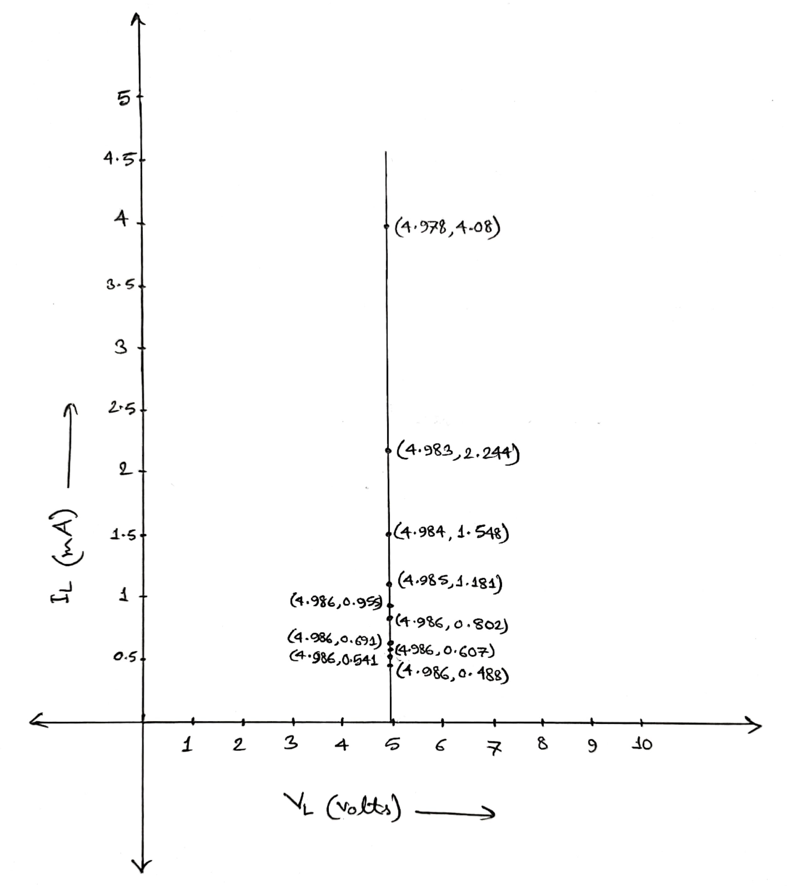

Figure 6: IL vs VL Graph using Table 2

**Answer to question 3:**

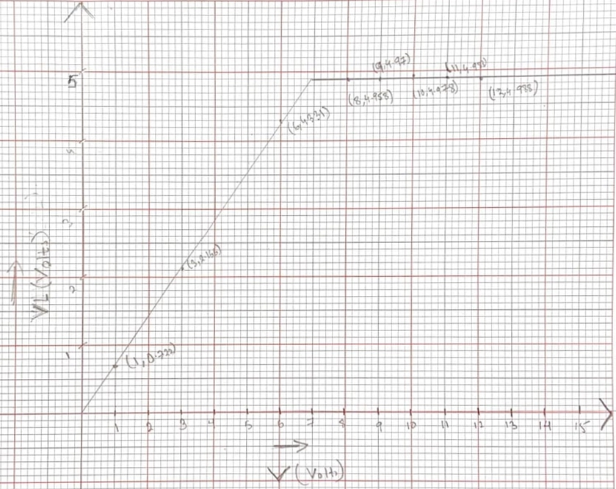

Figure 7: VL vs V Graph using Table 3

**Contributions:**

|  |  |
| --- | --- |
| **Name & ID** | **Contribution** |
| Tusher Saha Nirjhor – 1921793642  (**Report Writer)** | Data & Table |
| Fardin Bin Islam - 1721588642 | Questions/Answers |
| Md Kawser Islam – 1912296642 | Result Analysis & Discussion |
| Yusuf Abdullah Tonmoy – 1620456042 | Theory |
| Md. Rifat Ahmed - 1931725042 | Circuit Diagram, Equipment List, Attachment |

**Attachment:**

**Task: 01**

## Table 4.1: Data for I - V characteristics

|  |  |  |  |
| --- | --- | --- | --- |
| V  (volts) | VR  (volts) | Vz  (volts) | Iz = VR / R  (mA) |
| 0.1 | 9.448 µV | 99.991 mV | 19.999 nA |
| 0.7 | 66.13 µV | 699.934 mV | 139.988 nA |
| 1.0 | 94.472 µV | 999.906 mV | 199.984 nA |
| 3.0 | 283.414 µV | 3 V | 599.965 nA |
| 5.0 | 92.521 mV | 4.907 V | 196.848 µA |
| 6.0 | 1.044 V | 4.956 V | 2.221 mA |
| 10.0 | 5.013 V | 4.987 V | 10.665 mA |

Table 4.2: Data for Load Regulation

|  |  |  |  |
| --- | --- | --- | --- |
| POT_R (k ohm) | V220 (mV) | VL (volts) | IL (Amp)= V220/220 |
| 1 k | 897.643 mV | 4.978 V | 4.08 mA |
| 3 k | 340.542 mV | 4.984 V | 1.548 mA |
| 5k | 210.119 mV | 4.986 V | 955.092 µA |
| 9k | 118.981 mV | 4.986 V | 540.828 µA |
| 10k | 107.341 mV | 4.986 V | 487.92 µA |

Table 4.3: Data for Line Regulation.

|  |  |
| --- | --- |
| V (volts) | VL (volts) |
| 1.0 | 721.844 mV |
| 3.0 | 2.166 V |
| 6.0 | 4.331 V |
| 9.0 | 4.97 V |
| 10.0 | 4.978 V |
| 11.0 | 4.983 V |
| 12.0 | 4.988 V |

**Task: 02**

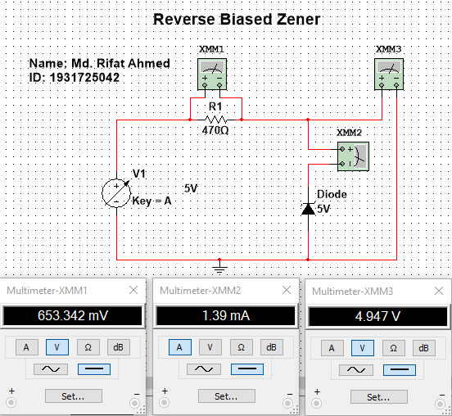

Figure 1: Reverse Biased Zener Circuit

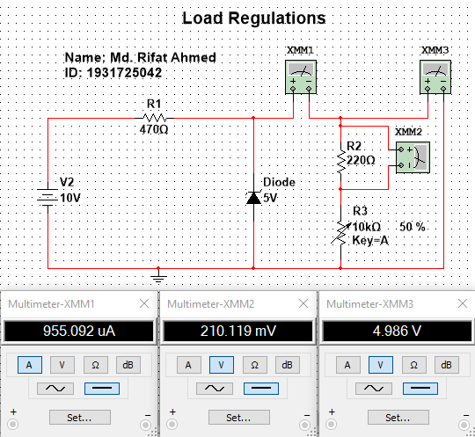

Figure 2: Load Regulations Circuit

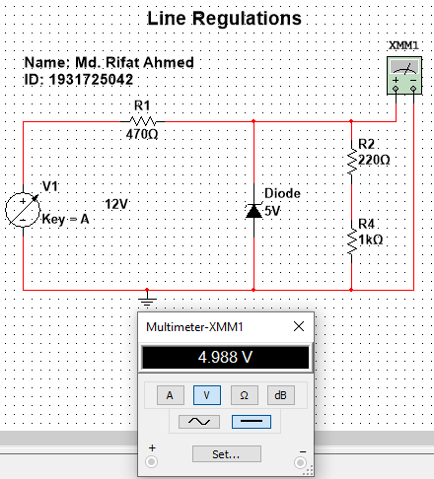

Figure 3: Line Regulations Circuit

**Task: 03**

1. What is the difference between a Zener Diode and a diode?

**Ans:** A normal diode only conducts in the forward bias region and does not conduct when reverse biased because they might be damaged if they’re reverse biased. But on the other hand, a Zener diode can conduct in three regions: forward, leakage and breakdown. In forward bias region it acts like a normal silicon diode, in the leakage region it can conduct a small amount of reverse saturation current and in the breakdown region it works for a fixed amount of voltage.

1. What is called a Zener Voltage?

**Ans:** The voltage that causes a diode to enter the Zener region in the negative bias region is called Zener voltage (VZ).

**References:**

Shaik, A. (2000, June 22). Zener diode - Definition, VI characteristics, and breakdown in Zener diode - Diode. XYZ. <https://www.physics-and-radio-electronics.com/electronic-devices-and-circuits/semiconductor-diodes/zenerdiode-definition-vicharacteristics-breakdowns.html>

Wikipedia contributors. (2021, July 22). Zener diode. Wikipedia. <https://en.wikipedia.org/wiki/Zener_diode>

Diode Application. (2005). In Electric Circuit and Electronics (5th ed., Vol. 2, pp. 1–122). Brothers. <http://site.iugaza.edu.ps/bhamed/files/2019/09/Chapter-2-Diode-Applications.pdf>